|  |  |
| --- | --- |
|  | |
| **Manchester City Centre & Specialist Markets**  Business Units  Neighbourhoods Directorate  Manchester City Council  Edwin House, Edwin Road  Beswick  Manchester M11 3ER |
|  |
|  |

Date: 16th October 2023

Attention: Manager

Dear Sir/Madam

**Manchester Christmas Market – Exchange Square & Corn Exchange 2023**

Manchester Markets are progressing plans for the Manchester Christmas Markets 2023, which will trade each day between 10 November and 21 December from 10.00am – 8.00pm (Bars & Food will be open until 9.00pm).

Exchange Square & Corn Exchange will once again be home to bespoke wooden houses which will be occupied for the full duration of the market. We will be working with each trader to ensure chalets are festively decorated and enhance the wonderful seasonal atmosphere that has made Manchester’s Christmas Markets a success year-on-year.

Exchange Square will still feature a bar area containing a food and drink provision. The bar area will be monitored by an SIA approved Security Officer during operating times.

We welcome your thoughts and suggestions regarding the Christmas Markets. Your input is invaluable in helping us develop and improve our markets and operations. If you would like to discuss the Christmas Markets, please contact me directly via email at dale.maybury@manchester.gov.uk

I look forward to welcoming you to the Manchester Christmas Markets 2023.

Yours sincerely

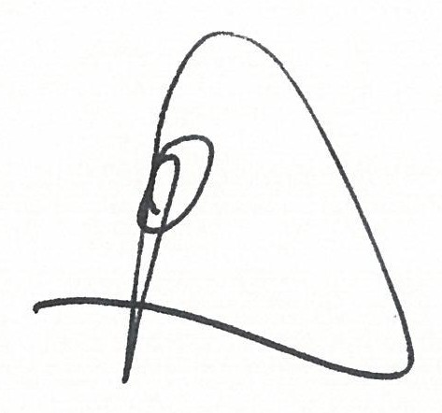

**Dale Maybury**

Head of City Centre & Specialist Markets