|  |
| --- |
|  |
| **Manchester City Centre & Specialist Markets**  Business Units  Neighbourhoods Directorate  Manchester City Council  Edwin House, Edwin Road  Beswick  Manchester M11 3ER |
|  |
|  |

Date: 16th October 2023

Attention: Manager

**Manchester Christmas Market – King Street 2023**

Manchester Markets are progressing plans for the Manchester Christmas Markets 2023.

Once again, King Street will be home to a number of European Christmas Market traders, featuring a variety of crafts and food in addition to a bar and café provision. For 2023 we are continuing to use the area from Police Street to Deansgate with small Christmas Houses open every day as everywhere else on the market.

The Market will trade each day from 10 November to 21 December between the hours of 10.00am to 8.00pm. The bar area will be open until 9.00pm and will be monitored by an SIA approved Security Officer during operating times. The catering operators will also close at 9.00pm.

* As per last year, all market traders will be informed of the market refuse collection point: container in South King Street.
* In past years, the main issue raised during the market concerned the shop’s refuse bags being left in their normal collection point. We would appreciate if you could inform all your staff and contractors about the change of refuse collection point in effect from 10 November to 21 December 2023.

- Corner of South King Street with Four Yards

- South King Street, opposite South Night Club.

As always, we will work hard to ensure that the operation of the market causes as little disruption to local shops and businesses as possible.

We welcome your thoughts and suggestions regarding the Christmas Markets. Your input is invaluable in helping us develop and improve our markets and operations. If you would like to discuss the Christmas Markets, please contact Dale Maybury via email at dale[.maybury@manchester.gov.uk](mailto:.maybury@manchester.gov.uk)

I look forward to welcoming you to the Manchester Christmas Markets 2023.

Yours sincerely

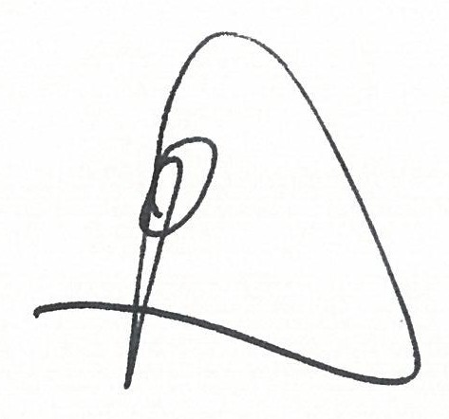

Dale Maybury

Head Of City Centre & Specialist Markets