|  |
| --- |
|  |
| **Manchester City Centre & Specialist Markets**  Business Units  Neighbourhoods Directorate  Manchester City Council  Edwin House, Edwin Road  Beswick  Manchester M11 3ER |
|  |
|  |

Date: 16th October 2023

**Market Street Businesses**

Attention: Manager

**Manchester Specialist Markets – 2023 Programme**

Manchester Markets are progressing plans for the Manchester Christmas Markets 2023, which will trade each day between 10 November and 21 December from 10.00am until 8.00pm. (6.00pm close on Sundays).

Market Street will be filled with festive spirit and will once again be home to bespoke wooden houses which will be occupied for the full duration of the market. Many of our customers’ favourite traders will be returning this year along with new high-end craft lines.

We will be working with each trader to ensure chalets are festively decorated and enhance the wonderful seasonal atmosphere that has made Manchester’s Christmas Markets a success year-on-year.

As per last year, this section of the market will not feature bar areas containing a food and drink provision. There will only be a single chalet offering freshly made coconut macaroons.

We welcome your thoughts and suggestions regarding the Christmas Markets. Your input is invaluable in helping us develop and improve our markets and operations. If you would like to discuss the Christmas Markets, please contact Dale Maybury via email at dale[.maybury@manchester.gov.uk](mailto:.maybury@manchester.gov.uk)

I look forward to welcoming you to the Manchester Christmas Markets 2023.

Yours sincerely

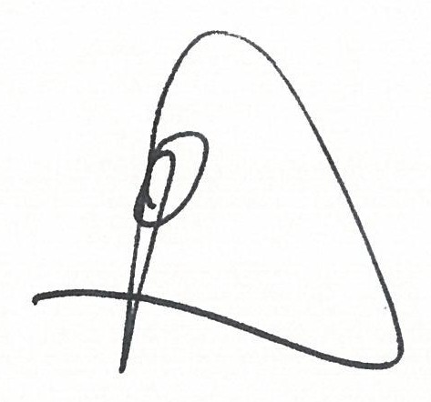

Dale Maybury

Head Of City Centre And Specialist Markets