|  |
| --- |
|  |
| **Manchester City Centre & Specialist Markets**  Business Units  Neighbourhoods Directorate  Manchester City Council  Edwin House, Edwin Road  Beswick  Manchester M11 3ER |
|  |
|  |

Date: 16th October 2023

**New Cathedral Street Businesses**

Attention: Manager

**Manchester Christmas Market –** **New Cathedral Street 2023**

Manchester Markets are progressing plans for the Manchester Christmas Markets 2023, which will trade each day between 10 November and 21 December from 10.00am – 8.00pm. (Food & Bars close at 9.00pm)

New Cathedral Street will once again be home to bespoke wooden houses which will be occupied for the full duration of the market. Many of our customers’ favourite traders will be returning this year along with new high-end craft lines. We will be working with each trader to ensure chalets are festively decorated and enhance the wonderful seasonal atmosphere that has made Manchester’s Christmas Markets a success year-on-year.

As per last year New Cathedral Street will feature a bar area containing a food and drink provision. The bar area will be monitored by an SIA approved Security Officer during operating times. We do not intend to have any outdoor music, and any background music in the Witch House will be monitored.

We welcome your thoughts and suggestions regarding the Christmas Markets. Your input is invaluable in helping us develop and improve our markets and operations. If you would like to discuss the Christmas Markets, please contact Dale Maybury via email at dale[.maybury@manchester.gov.uk](mailto:.maybury@manchester.gov.uk)

I look forward to welcoming you to the Manchester Christmas Markets 2023.

Yours sincerely

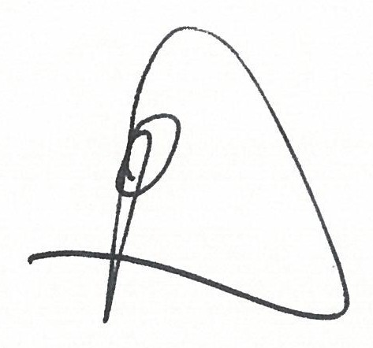

**Dale Maybury**

Head Of City Centre & Specialist Markets