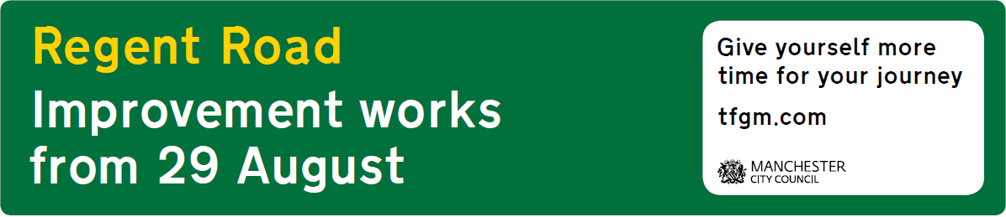

Important information: Manchester and Salford Inner Relief Route (MSIRR) improvement scheme – potential disruption to travel for 12 months

Starting on Wednesday 29 August, Manchester City Council and Salford City Council will begin major improvement works on six junctions on and around Regent Road.

Once complete the £15 million Manchester and Salford Inner Relief Route improvement (MSIRR) scheme will help to ease congestion on one of the busiest routes into and out of Manchester city centre from Salford - increasing capacity by up to 20%.

The work is scheduled to take 12 months to complete and during this time Regent Road will be reduced from two lanes to one lane in each direction. As a result, journey times are expected to increase significantly, especially during the morning and evening peaks.

The six junctions set to be affected include:

- The junction of Dawson Street, Regent Road, Trinity Way and Water Street.
- The junction of Regent Road and Ordsall Lane (Salford).
- The junction of Regent Road and Oldfield Road (Salford).
- The Mancunian Way, A56, A5067 roundabout.
- The junction of Trinity Way and Hampson Street.
- The junction of Hampson Street, East Ordsall Lane and Middlewood Street.
For more information about the scheme, please visit manchester.gov.uk/MSIRR
Travel advice:

On Monday 13 August, Transport for Greater Manchester (TfGM) launched a bespoke Manchester and Salford Inner Relief Route webpage at tfgm.com/regent-road to help people plan their journeys while this work takes place.

The work to Regent Road is expected to cause delays on other nearby routes including the M602 and Mancunian Way, while surrounding routes – such as Chester Road, Princess Road, A580 East Lancs Road, Trinity Way, Hyde Road, Stockport Road and Ashton Old Road – will likely be much busier than usual.

The advice for motorists is to plan ahead, allow extra time for journeys, use public transport where possible and use alternative routes during the morning and evening peaks. Road users should avoid using the M602 to travel into the city centre if possible and use alternative city centre exits from the M60.

As mentioned, journey times for motorists will significantly increase, for example:
- During the morning peak, travel into the city centre via the M602, Regent Road and on to the Mancunian Way is expected to increase from around 15-20mins to at least 25-30mins.

- During the evening peak, journeys out of the city centre along the Mancunian Way, Regent Road and on to the M602 are expected to increase from around 20-25mins to at least 40-45mins.

Drivers should consider using public transport where it is an option – or consider cycling or walking if they are able to do so.

How can you help?:
To help people get around the city-region, it’s important that information about the project is distributed far and wide. For that reason we’d be grateful if you could communicate details about the work to your staff, visitors and customers. If you need any social media messages, images or other marketing materials to support this, please contact communications@manchester.gov.uk.
Contact details
- For more information about the work, including maps of the roads affected, visit Manchester City Council’s website at www.manchester.gov.uk/MSIRR

- For the latest travel advice be sure to visit the TfGM website regularly at www.tfgm.com/regent-road. Also follow on Twitter @OfficialTfGM

