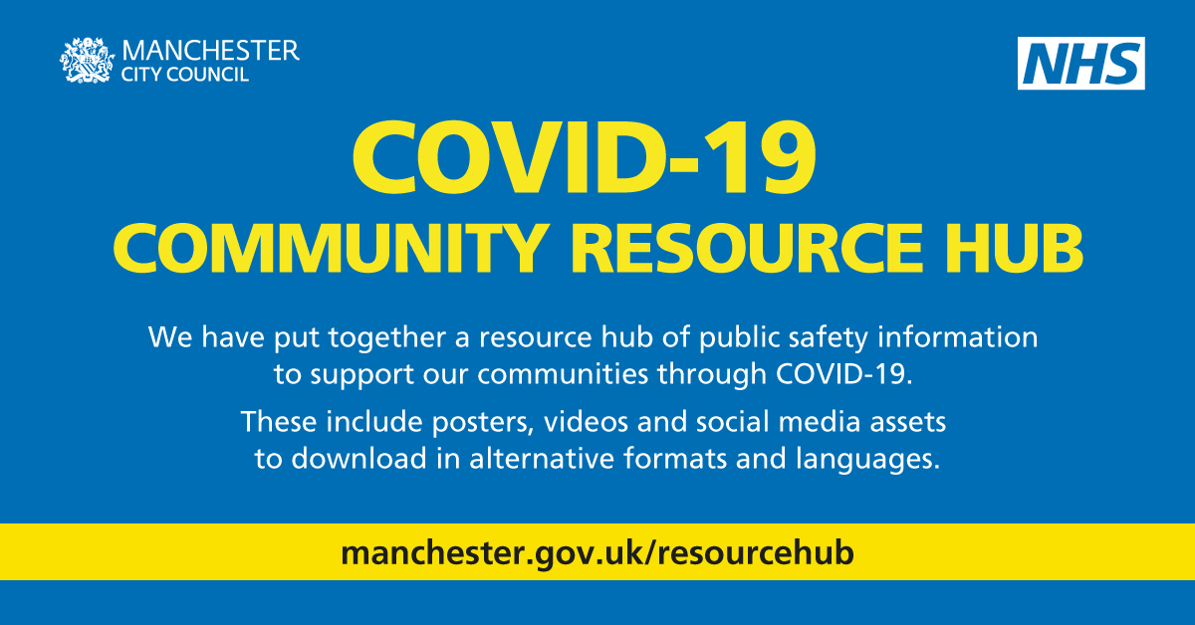

Test and Trace – supporting our Manchester communities

As Manchester’s rates are increasing. It is really important for us all to work together to get messages out and engage our communities in a way that supports them to understand and know what they need to do to keep themselves and others safe.

Manchester is made up of many diverse people and communities, so we have developed a set of assets that are accessible, some of which are available in other languages that will help to support them. These are available directly from our Resource Hub at www.manchester.gov.uk/resourcehub

Our residents and communities need to know what they are expected to do:

- IF they need to get a test
- IF they need to self-Isolate
- How long they should self-isolate for
- How they can stop the spread of the virus

How you can help support Manchester communities
We need you to share content and messages across all of your channels, in your conversations and in local community areas where you have interactions with our people.

We need you to help break through any barriers that people might have to allow them to access the information that they need in the way they need it.

What’s included in this toolkit

- Copy and icon for you to share on emailer/newsletter/webpage etc that explains how Test and Trace works
NOTE: We have developed these messages into audio files in 13 commonly used languages in Manchester – these are available directly from our Resource Hub at www.manchester.gov.uk/resourcehub
OR from
barry.cooper@manchester.gov.uk – example is added to this email

- There is a British Sign Language version – link attached here
BSL Test and Trace videolink https://youtu.be/CeN5Rz1BaeM

- 3 x Videos (subtitled) from Manchester’s Public Health Team that explains Test and Trace and how it works – Links here

- What to do if you have symptoms: https://youtu.be/lLG5QFuF26M
- What to do if you are a contact: https://youtu.be/3eZrwbEMJu4
- Incubation period: https://youtu.be/uCtWTp8Z0Pw

- Social media digital assets and messages for you to use or share - attached to this email

- Poster for you to use across your networks - attached to this email

Copy to share on Social Media/emailer/newsletter/webpages etc:

COPY and ICON – 119 free test icon
The three messages in English are:

Message 1
If you think you might have Coronavirus you can now have a test.

Signs of Coronavirus are:
A high temperature
Or a new and continuous cough
Or loss of smell and taste

If you or anyone you live with has any of these signs, you must stay at home.

You can get a test and find out how long to stay home by ringing 119 or logging on to nhs.uk/coronavirus

Message 2
If you have been close to someone who has tested positive for Coronavirus
you will be contacted about it by phone, text or email.

If you are contacted you must self-isolate for 14 days.

more information is on nhs.uk/coronavirus

Message 3
To stay healthy and well and to stop the spread of coronavirus, please:

Keep washing your hands well;
Keep social distancing rules;
Sneeze or cough into your arm or a tissue
Wipe surfaces and handles
And Look after yourself.

www.manchester.gov.uk/coronavirus

Message 4

Do you or someone you live with have any of the following symptoms?
- a high temperature
- a new, continuous cough
- a loss or change to your sense of smell or taste?

Isolate with the people people you live with and get a free COVID-19 test as soon as possible call 119 or www.nhs.uk/coronavirus

Thank you for your support

